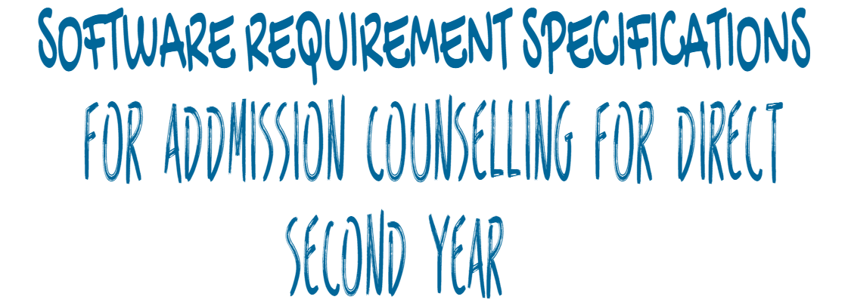

**Index**

1. Introduction
   * Purpose
   * Scope
   * Definition
   * Product and its function
   * Benefits and Goals

**2**.Overall Description

* Product Description
* Product Functioning
* Functions of Project
* Users of Project

**3.**Specific Requirements

* + Interface Requirements
  + Hardware Requirements
  + Software Requirements
  + Logical Database Requirements

**4.**Basic Processing Action of the System Appendices

* + UML Model

**Introduction**

**Purpose*:***

The purpose of Admission Counselling For Direct Second Year is to know students of Diploma where they can take Admission for BE/BTech with the percentage he/she got which best out best college he/she can get based on Previous Year Data.

**Scope:**

            Students can check List of Colleges available in Maharashtra, Top Colleges admission details of students who had taken admission last year. The main purpose of this project is

* **Display colleges in Maharashtra**
* **Last year cut-off list**
* **Show seat matrix/availability**
* **Top Colleges Admission**
* **All India Colleges**
* **Outside Maharashtra Colleges**
* **Which College I can take Admission.**

The scope of this project is that for knowing where a student can take admission is that, we can analyse the Medical, MBA, first year engineering. By this one project we can able to analyse different admission process. By analysing this we can create a life process graph how a student is growing where he/she has taken admission’s and

**Definition:**

            This is a project, which is used to know complete admission details for Direct Second Year (Lateral Entry).

**Product & its functions:**

            The Product of this project is a website for Admission Counselling for Direct Second Year, which is to know where diploma students can take admission, How many colleges available in Maharashtra for admission, Colleges outside Maharashtra which are providing admission for Lateral Entry and Top Colleges admission details.

**Benefits and Goals:**

            The Benefit of this project is to reduce the work of Student for searching where he/she can take admission. Which are the best colleges he/she can take admission based on the percentage they got. This is the major benefits of the project.

            The Goals of this project is that, to give diploma student best out of best college based on his/her percentage. And to reduce the work of searching which colleges are available for admission in Maharashtra and Outside Maharashtra this are the main goals behind making of this project.

**Overall Description**

**Product Description:**

            The student enters his/her details like: Branch, college type, percentage, city, category, seat type, gender and shift and will came to know where he/she can take admission. And which are the colleges willing to take lateral entry admission. The website will show which are the top best colleges available where you can take admission.

**Product Functioning:**

·        The website takes the detail from the student.

·        The web-server will check’s whether the details are correct or not.

·        If student details are correct, then it will show college list where admission can be taken.

**Functions of Project:**

            There are seven functionalities provided by the Admission Counselling for Direct Second Year website.

• **Display colleges in Maharashtra**: This page will display colleges available in Maharashtra based on city and college type.

• **Last year cut-off list:** This page will display the cut off list of last year college admission minimum percentage and maximum percentage required to get admission.

• **Show seat matrix/availability:** This page will display the vacant seat available in college for admission.

• **Top Colleges Admission:** This page will show top 10 colleges of Maharashtra where last year student have taken admission.

• **All India Colleges:** This page will show all engineering colleges of India.

• **Outside Maharashtra Colleges:** This page will display outside Maharashtra colleges which are giving admission for lateral entry.

• **Which College I can take Admission:** This page will display colleges where you can take admission based on certain parameter.

**Users of Project**:

Student: This person uses this system to find where he/she can take admission.

**Specific Requirements**

**Interface Requirements:**

            The interface requirements of Railway Reservation System include

1. Easy to Navigate.
2. Less Graphics
3. Display Error Messages and Relevant Dialogue Boxes
4. Providing high security such that not to be modified by irrelevant users.
5. It must provide an options such that to reduce the input actions by uses.

**Hardware Requirements:**

            The hardware requirements of this system is given by

1. 20 MB of Memory
2. 512 Ram
3. Internet Connection

**Software Requirements:**

            The software requirements of this are as follows:

1. Browser
2. Windows or Android or MAC OS

**Logical Database Requirements:**

        The following information is to be stored in the database

1. All India College’s list
2. Allocated College’s details
3. List of College’s in Maharashtra
4. Outside Maharashtra College List
5. Diploma Result List

**Basic Processing Actions of the System Appendices**

**UML**

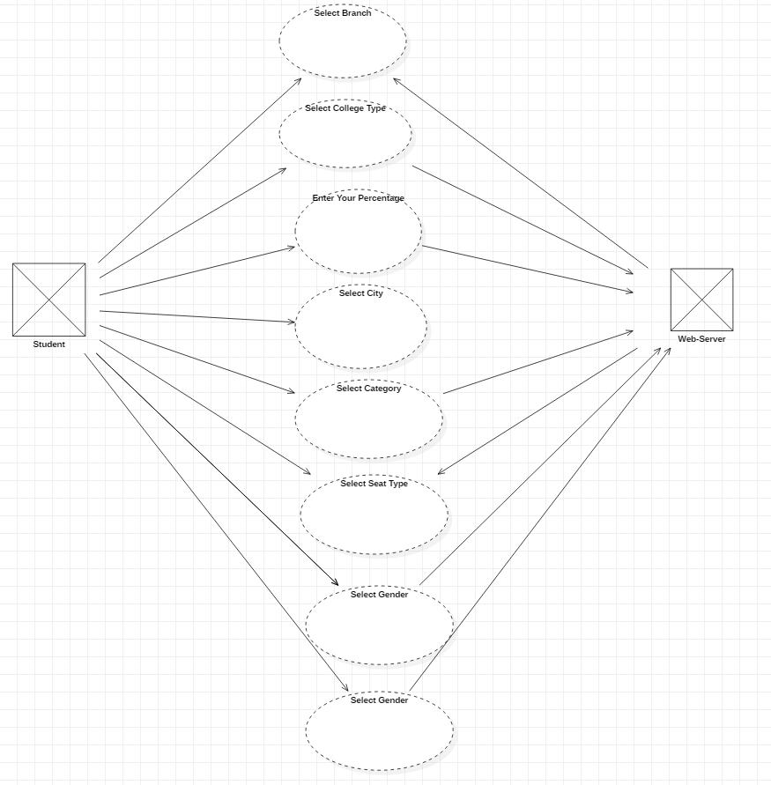

**Test Cases:**

|  |  |  |  |  |  |  |  |
| --- | --- | --- | --- | --- | --- | --- | --- |
| **TC_ID** | **TC_NAME** | **Area** | **ACTIONs** | **INPUT DATA** | **EXPECTED RESULT** | **ACTUAL RESULT** | **STATUS** |
| TC_01 | Net Connection | Browser | Searching on Browser | [https://www.counselling-dse.com](https://www.counselling-dse.com/) | It should open Website i.e Net Connection Available | Opening website | Pass |
| TC_02 | ReSize | Home Page | Resize web browser |  | It should display content properly | Displaying | Pass |
| TC_03 | Logo | Home Page | Click on Logo image |  | It should go to home page | Going to Home page | Pass |
| TC_04 | Navigation | Home Page | Click on Navigation Bar |  | It should display navigate content | Displaying | Pass |
| TC_05 | Link | Home Page | Click on links available | About Page | It should go to particular link | Going to College In Maharashtra Page | Pass |
| TC_06 | Post | Home Page | Click on particular post |  | It should go to particular post | Displaying Post | Pass |
| TC_07 | Search | Post Page | Click on search icon | Search: C Programs | It should display search result | Displaying Search Data | Pass |
| TC_08 | Top College Addmission | Home Page | Click on top college addmission |  | It should display top colleges | Displaying top colleges | Pass |
| TC_09 | Reload | About Page | Click on Reload button |  | It should reload same page | Displaying Same Page | Pass |
| TC_10 | India Colleges | Home Page | Click on all India colleges |  | It should display all India Colleges | Displaying all India Colleges | Pass |
| TC_11 | Where I can take admission | |  | | --- | | Admission Page | | Enter Percentage between 0 to 100 | 102 | It should display you cannot enter more than 100 | Displaying you cannot enter more than 100 percentage | Pass |